**COURSE FILE**

***ON***

**“ADHOC AND SENSOR NETWORKS”**

**IV B-Tech II Semester**

****

**INFORMATION TECHNOLOGY**

**CMR TECHNICAL CAMPUS**

**KANDLAKOYA (V), MEDCHAL (M), R.R.DIST.**

**CONTENTS OF COURSE FILE:**

1. Department vision & mission
2. List of PEOs , POs & PSOs
3. List of COs(Action verbs as per Bloom's Taxonomy)
4. Syllabus Copy and Suggested/Reference Books
5. Session Plan/Lesson Plan
6. Session execution log
7. Lecture Notes (Hand Written)
8. Assignment Questions along with sample Assignments Scripts
9. Mid exam Question Papers along with sample Answers Scripts
10. Scheme of Evaluation
11. Mapping of COs with POs and PSOs
12. Attainment of COs,POs and PSOs (Excel Sheet)
13. University Question Papers/ Question Bank
14. Power point presentations (PPTs)
15. Websites/URLs/ e- Resources

**1. DEPARTMENT VISION & MISSION**

**VISION:**

To produce globally competent and industry ready graduates in Computer Science & Engineering by imparting quality education with a know-how of cutting edge technology and holistic personality.

**MISSION:**

**M1**. To offer high quality education in Computer Science & Engineering in order to build core competence for the students by laying solid foundation in Applied Mathematics, and program framework with a focus on concept building.

**M2**. The department promotes excellence in teaching, research, and collaborative activities to prepare students for professional career or higher studies.

**M3**. Creating intellectual environment for developing logical skills and problem solving strategies, thus to develop, able and proficient computer engineer to compete in the current global scenario.

**2. LIST OF PEOS, POS & PSOS**

**2.1 Program Educational Objectives (PEO):**

**PEO 1:** Excel in professional career or higher education by acquiring knowledge in mathematical, computing and engineering principles.

**PEO 2:** To provide intellectual environment for analyzing and designing computing systems for technical problems socially and economically.

**PEO 3:** Exhibit professionalism, multidisciplinary teamwork and adapt to current trends by engaging in lifelong learning and practice their profession with legal and ethical responsibilities.

**2.2 .Program Outcomes (PO):**

* **PO1**. An ability to apply knowledge of computing, mathematics, science and engineering fundamentals appropriate to the discipline.
* **PO2**. An ability to analyze a problem, and identify and formulate the computing requirements appropriate to its solution.
* **PO3.** An ability to design, implement, and evaluate a computer-based system, process, component, or program to meet desired needs with appropriate consideration for public health and safety, cultural, societal and environmental considerations.
* **PO4**. An ability to design and conduct experiments, as well as to analyze and interpret data.
* **PO5**. An ability to use current techniques, skills, and modern tools necessary for computing practice.
* **PO6**An ability to analyze the local and global impact of computing on individuals, organizations, and society.
* **PO7.** Knowledge of contemporary issues.
* **PO8.** An understanding of professional, ethical, legal, security and social issues and responsibilities.
* **PO9.** An ability to function effectively individually and on teams, including diverse and multidisciplinary, to accomplish a common goal.
* **PO10.** An ability to communicate effectively with a range of audiences.
* **PO11.** An understanding of engineering and management principles and apply these to one’s own work, as a member and leader in a team, to manage projects.
* **PO12.** Recognition of the need for and an ability to engage in continuing professional development.

**NBA Graduate Attributes**

PO1 Engineering knowledge

PO2 Problem analysis

PO3 Design/development of solutions

PO4 Conduct investigations of complex problems

PO5 Modern tool usage

PO6 The engineer and society

PO7 Environment and sustainability

PO8 Ethics

PO9 Individual and team work

PO10 Communication

PO11 Project management and finance

PO12 Life-long learning

**2.3.PROGRAM SPECIFIC OUTCOMES (PSO’s)**

|  |  |
| --- | --- |
| PSO1: | **Professional Skills and Foundations of Software development:** Ability to analyze, design and develop applications by adopting the dynamic nature of Software developments. |
| PSO2: | **Applications of Computing and Research Ability**: Ability to use knowledge in cutting edge technologies in identifying research gaps and to render solutions with innovative ideas. |

**3. LIST OF COS(ACTION VERBS AS PER BLOOM'S TAXONOMY)**

|  |  |
| --- | --- |
| CO1 | **Explain the** overview of the physical, networking and architectural issues of mobile adhocnetworks |
| CO2 | **Analyze** the various sensor networks and the unique set of design challenges |
| CO3 | **Evaluate** measurement of protocol performance in sensor networks |
| CO4 | **Illustrate** the major design issues, including topics such as protocol mechanisms and resource constraints. |
| CO5 | **Implement** algorithms involved in ad-hoc/sensor systems. |
| CO6 | **Design** the Automated Building Climate Control by using TOSSIM |

**4. SYLLABUS COPY AND SUGGESTED/REFERENCE BOOKS**

**UNIT-I**

**objective:**

* Knowledge about the MANET
* To know the MANET application
* To know the limitation of MANETS
* Knowledge about the Topology-based versus positions
* Knowledge about the Topology based routing protocols & other routing protocols

**SYLLABUS**

**Introduction to ad hoc wireless networks:**characteristics of MANETs , Application of MANETs, challenges

**Topology-based versus positions**- based approaches, topology based routing protocols, positions based routing, other routing protocols

**UNIT – II**

**objective**

* To know the Mobile Network Layers
* Knowledge about the MOBILE IP
* Knowledge about the IP PACKET DELIVERY
* Knowledge about the DHCP

**SYLLABUS**

**Data Transmission In Manets**: The broadcast storm multicasting, geocasting

**Tcp Over Ad Hoc Networks**: TCP protocol overview, TCP and MANETs, solutions for TCP over Ad Hoc.

**UNIT – III**

**objective**

* Knowledge about Basics of wireless sensors.
* To know theapplication wireless sensors
* Knowledge about the Clustering of Sensors
* Knowledge about WSNs
* To knowMAC layer routing layer .

**SYLLABUS**

**Basics of wireless sensors and applications:** The Mica Mote, Sensing and Communication Range, Design Issues, Energy consumption, Clustering of Sensors, Applications.

**Data retrieval in sensor networks:** classification of WSNs, MAC layer routing layer , high level application layer support, adapting to the inherent dynamic nature of WSNs.

**UNIT – IV**

**objective**

* Knowledge about security in WSNs
* Knowledge about security in MANETs

**SYLLABUS**

**SECURITY:** security in ad-hoc wireless networks, key management, secure routing cooperation in MANETs, instruction detection system.

**Sensor network platforms and tools:**Sensor network hardware,sensor network programming challenges, Node-Level software Platforms.

**UNIT – V**

**objective**

* Knowledge about the **Sensor network**Platforms **and tools**
* Knowledge about the Node-Level software Platforms
* Knowledge about TinyOS
* Knowledge about the TinyGALS
* Knowledge about the TOSSIM

**SYLLABUS**

**Operating system**-TinyOS

**Imperative language**: nesC, Dataflow style language: TinyGALS, Node-level Simulators, ns-2 and its sensor networks extension, TOSSIM.

**Suggested Books**

**TEXTBOOKS:**  
**T1**. Ad Hoc and sensor networks, Carlos Corderio Dharma P.Aggarwal, world scientific publication/ Cambridge university press, March 2006

**T2**. Wireless sensor networks: An information processing approach, Feng Zhao, Leonidas Guibas, Elsevier Science imprint, Morgan Kauffman publishers, 2005,rp2009

**REFERENCE BOOKS**

**R1**. Ad hoc Wireless Networks- Architecture and Protocols, C.Siva Ram Murthy, B.S.Murthy, Pearson Education

**R2**. Wireless sensor networks-Principles and Practice, FeiHu, Xiaojun Cao, An Auerbach book CRC press.

**R3** Wireless Ad Hoc Mobile wireless Networks- principle, protocols and applications, Subir Kumar Sarkar , et al.,Auerbach publications, Taylor & Francis Group,2008

**R4**. Ad Hoc networking, Charles E.Perkins, Pearson Education,2011.

**R5.wireless** Ad Hoc Networking , Shih-LinWu, Yu-Chee Tseng, Auerbach publications, Taylor & Francis group, 2007

**R6.** Wireless Ad Hoc and sensor networks-Protocols, Performance and Control, Jagnnathan Sarangapani,CRC press,Taylor & Francis group, 2007

**R7.**SecurityAd Hoc and sensor networks, Raheem Beyah, et al World Scentific Publications/ Cambridge University Press, 2010

**R8**.Ad hoc Wireless Networks –A communication –theoretic perspective, Ozan K.Tonguz, Gialuigi Ferrari,Wiley India

**R9.**Wireless Sensor Networks –Signal Processing and communication perspectives, Ananthram Swami, Wiley Induia

**5.SESSION PLAN/LESSON PLAN**

|  |  |  |  |  |  |  |
| --- | --- | --- | --- | --- | --- | --- |
| **Lecture No.** | **JNTUH Topic** | **Objective of each Topic** | | **Practical inferences** | **Method of Teaching** | |
| **L1,L2** | Introduction to ad hoc wireless networks | Introduction to ad hoc wireless networks . | | Understand the concept of ad hoc wireless networks | **M1** | |
| **L3,L4** | Characteristics of MANETs. | Explanation about Characteristics of MANETs | | Understand the distinctive features of MANET | **M1,M7** | |
| **L5,L6** | Application of MANETs, challenges | Explanation about the basic applications of MANET | | Strong background knowledge about MANETs | **M1,M7** | |
| **L7** | Topology-based versus positions Based Approaches | Explanation about the the difference between Topology-based with position Based Approaches | | Understand the classification of Routing over ad hoc networks | **M1** | |
| **L8,L9,L10** | Topology Based Routing Protocols | Explanation about proactive ,reactive and hybrid Routing approaches | | Understand topology based protocols | **M1 &M4** | |
| **L11,L12** | Positions Based Routing | Explanation about ad hoc routing protocols that use location information | | Understand the routing protocols that take the advantage of location services in routing | **M1 ,M4** | |
| **L13,L14** | Other Routing Protocols | Explanation about ad hoc routing protocols that use optimization criteria | | Understand the protocols in MANETs that use optimization criteria | **M1 ,M4** | |
| **L15** | Data Transmission In Manets | Explaining the basics of data transmission in MANETs | | Understand the different types of data transmission in MANETs | **M1** | |
| **L16,L17** | The broadcast storm | Explanation about the broadcasting in MANETs and its protocols | | Understand in detail about broadcasting with neighbours in MANETs  . | **M1** | |
| **L18,19** | multicasting | Explanation about delivering a message to a subset of manets | | Understand the problem of multicasting in MANETs | **M1,M4** | |
| **L20,21** | Geocasting | Explanation of the Geocasting and its protocols | | Understanding multicasting within the members in a specified geographical location | **M1,M4** | |
| **L23** | Tcp Over Ad Hoc Networks | Explanation about the transmission control protocol over Ad Hoc | | Understand the Tcp Over Ad Hoc Networks | **M1** | |
| **L24** | TCP protocol overview | Explanation about the transmission control protocol | | Review the transmission control protocol | **M1** | |
| **L25** | TCP and MANETs | Explanation about the differences between TCP and MANETs | | Understand the differences between TCP and MANETs | **M1** | |
| **L26** | Solutions For TCP over Ad Hoc | Explanation of Solutions For TCP over Ad Hoc | | Useful to understand hoe to solve the problems identified in TCP | **M1** | |
| **L27** | Basics of wireless sensors and applications | Explanation about wireless sensors and applications | | To Understand the Basics of wireless sensors and applications | **M1** | |
| **L28** | The Mica Mote | Explanation about The Mica Mote | | To Understand the mote module used for low power, wireless sensor networks | **M1** | |
| **L29** | Sensing and Communication Range, | Explanation about Sensing and Communication Range in WSNs | | To explore the best possible use of large no. of SNs in WSN | **M1** | |
| **L30** | Design Issues | Explanation about Design Issues in WSNs  . | | Understand the challenges in designing WSNs | **M1** | |
| **L31** | Energy consumption | Explanation about Energy consumption in WSNs | | Understand the minimization of energy consumption in WSNs | **M1** | |
| **L32** | Clustering of Sensors, Applications | Explanation for Clustering of Sensors, Applications | | Understandthe Clustering of Sensors and applications of WSNs | **M1** | |
| **L33** | Data retrieval in sensor networks | Explanation about the Data retrieval in sensor networks | | Understand  Data retrieval in sensor networks | **M1** | |
| **L34** | Classification of WSNs | Explanation about the categories of WSN | | Understand  Classification of WSNs | **M1** | |
| **L35** | MAC layer routing layer | Explanation about MAC layer routing layer | | Understand the  MAC layer routing layer | **M1** | |
| **L36** | High Level Application Layer Support | Explanation about High Level Application Layer Support. | | Learn  High Level Application Layer Support | **M1** | |
| **L37** | Adapting To The Inherent Dynamic Nature Of Wsns | Overview about Dynamic Nature Of Wsns | | Learntechniques of Adapting To The Inherent Dynamic Nature Of Wsns | **M1** | |
| **L38** | Security In Ad Hoc Wireless Networks | Overview of the security issues over ad hoc and sensor networks | | To understand thesecurity issues over ad hoc and sensor networks | **M1** | |
| **L39.l40** | Key Management | Description of the dominant key management paradigms that have been developed for ad hoc networks | | To understand the Key Management algorithms | **M1** | |
| **L41,L42** | Secure Routing Cooperation In Manets | Explanation of Secure Routing Cooperation In Manets | | To understand the Secure Routing Cooperation In Manets | **M1** | |
| **L43** | Intrusion Detection System | Explanation about IDS techniques, architecture and anomaly detection | | To understand **I**ntrusionDetection System for Ad Hoc and Sensor Networks | **M1** | |
| **L44** | Security In Ad Hoc Wireless Networks | Explanation about Security In Ad Hoc Wireless Networks | | To understand Security In Ad Hoc Wireless Networks | **M1** | |
| **L45,46** | Sensor networkPlatforms and tools | Explanation about Sensor networkPlatforms and tools. | | To understandSensor networkPlatforms and tools | **M1** | |
| **L47** | Sensor network hard ware | Explanation about Sensor network hard ware | | To understandSensor network hardware | **M1** | |
| **L48** | Sensor Network Programming Challenges | Explanation aboutSensor Network Programming Challenges | | To learn the risks and challenges in Sensor Network Programming Challenges | **M1** | |
| **L49** | Node-Level software Platforms. | Overview of Node-Level software Platforms | | To learn the platforms Node-Level software Platforms | **M1** | |
| **L50** | Operating system-TinyOS | Explanation about tiny OS | Understand component-based operating system(tiny os) and platform targeting wireless sensor networks (WSNs). | | | **M1** | |
| **L51** | Imperative language: nesC,Dataflow style language | Explanation about nesC | Understand nesC*-*programming language *to understand the whole method of. TinyOS-application* | | | **M1** | |
| **L52,L53** | TinyGALS | Explanation about TinyGALS | Understand the Programming Model for Event-Driven Embedded Systems | | | **M1** | |
| **L54,55** | Node-level Simulators | Explanation about Node-level Simulators | Understand the Node-level Simulators | | | **M1** | |
| **L56** | ns-2 and its sensor networks extension | Explanation about ns-2 and its sensor networks | Understand the sensor network simulations | | | **M1** | |
| **L57** | TOSSIM | Explanation about **TOSSIM** framework | Understand how to compile tiny OS application into the **TOSSIM** framework | | | **M1** | |

**6. Session Execution Log:**

|  |  |  |  |  |
| --- | --- | --- | --- | --- |
| **S no** | **unit** | **Scheduled completed date** | **Completed date** | **Remarks** |
| **1** | **I** | **14-12-2017** | **29-12-2017** |  |
| **2** | **II** | **2-01-2018** | **21-01-2018** |  |
| **3** | **III** | **22-01-2018** | **15-02-2018** |  |
| **4** | **IV** | **18-02-2018** | **28-02-2018** |  |
| **5** | **V** | **2-03-2018** | **28-03-2018** |  |

**7. Lecture Notes –(hand written)**

**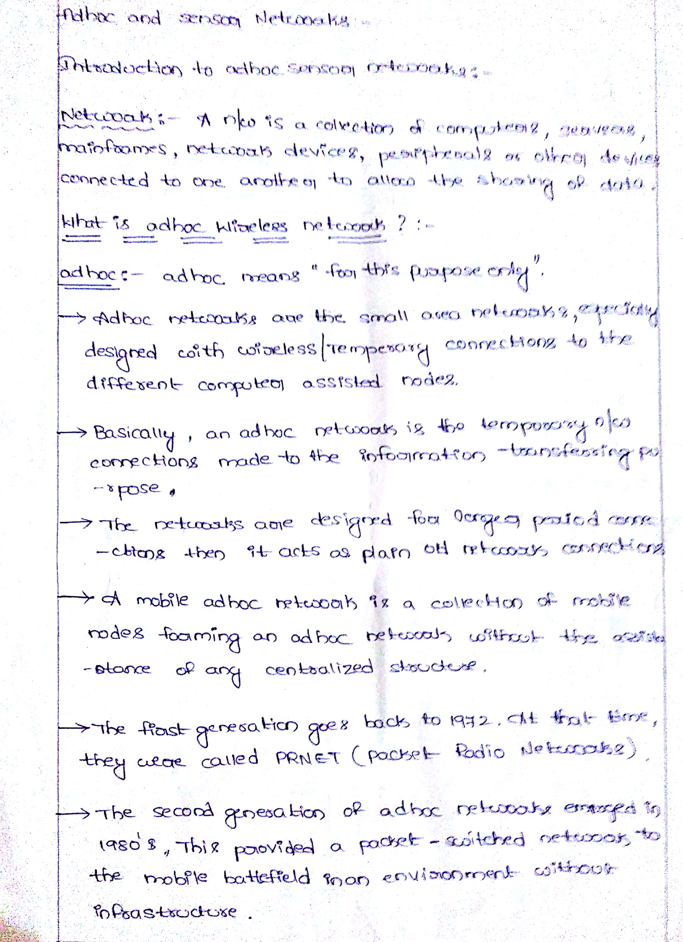**

**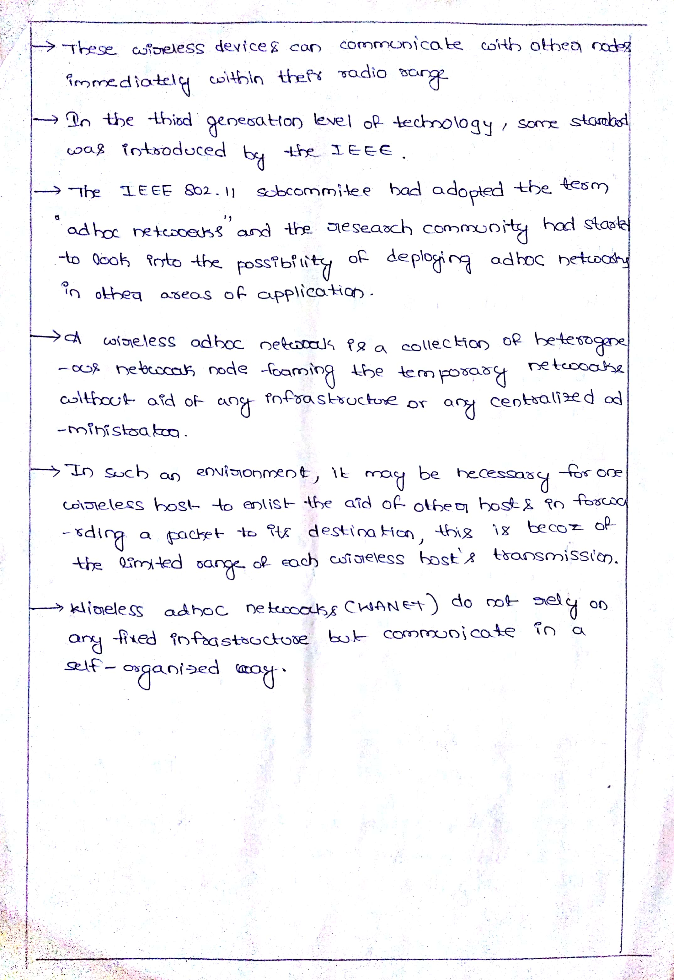**

**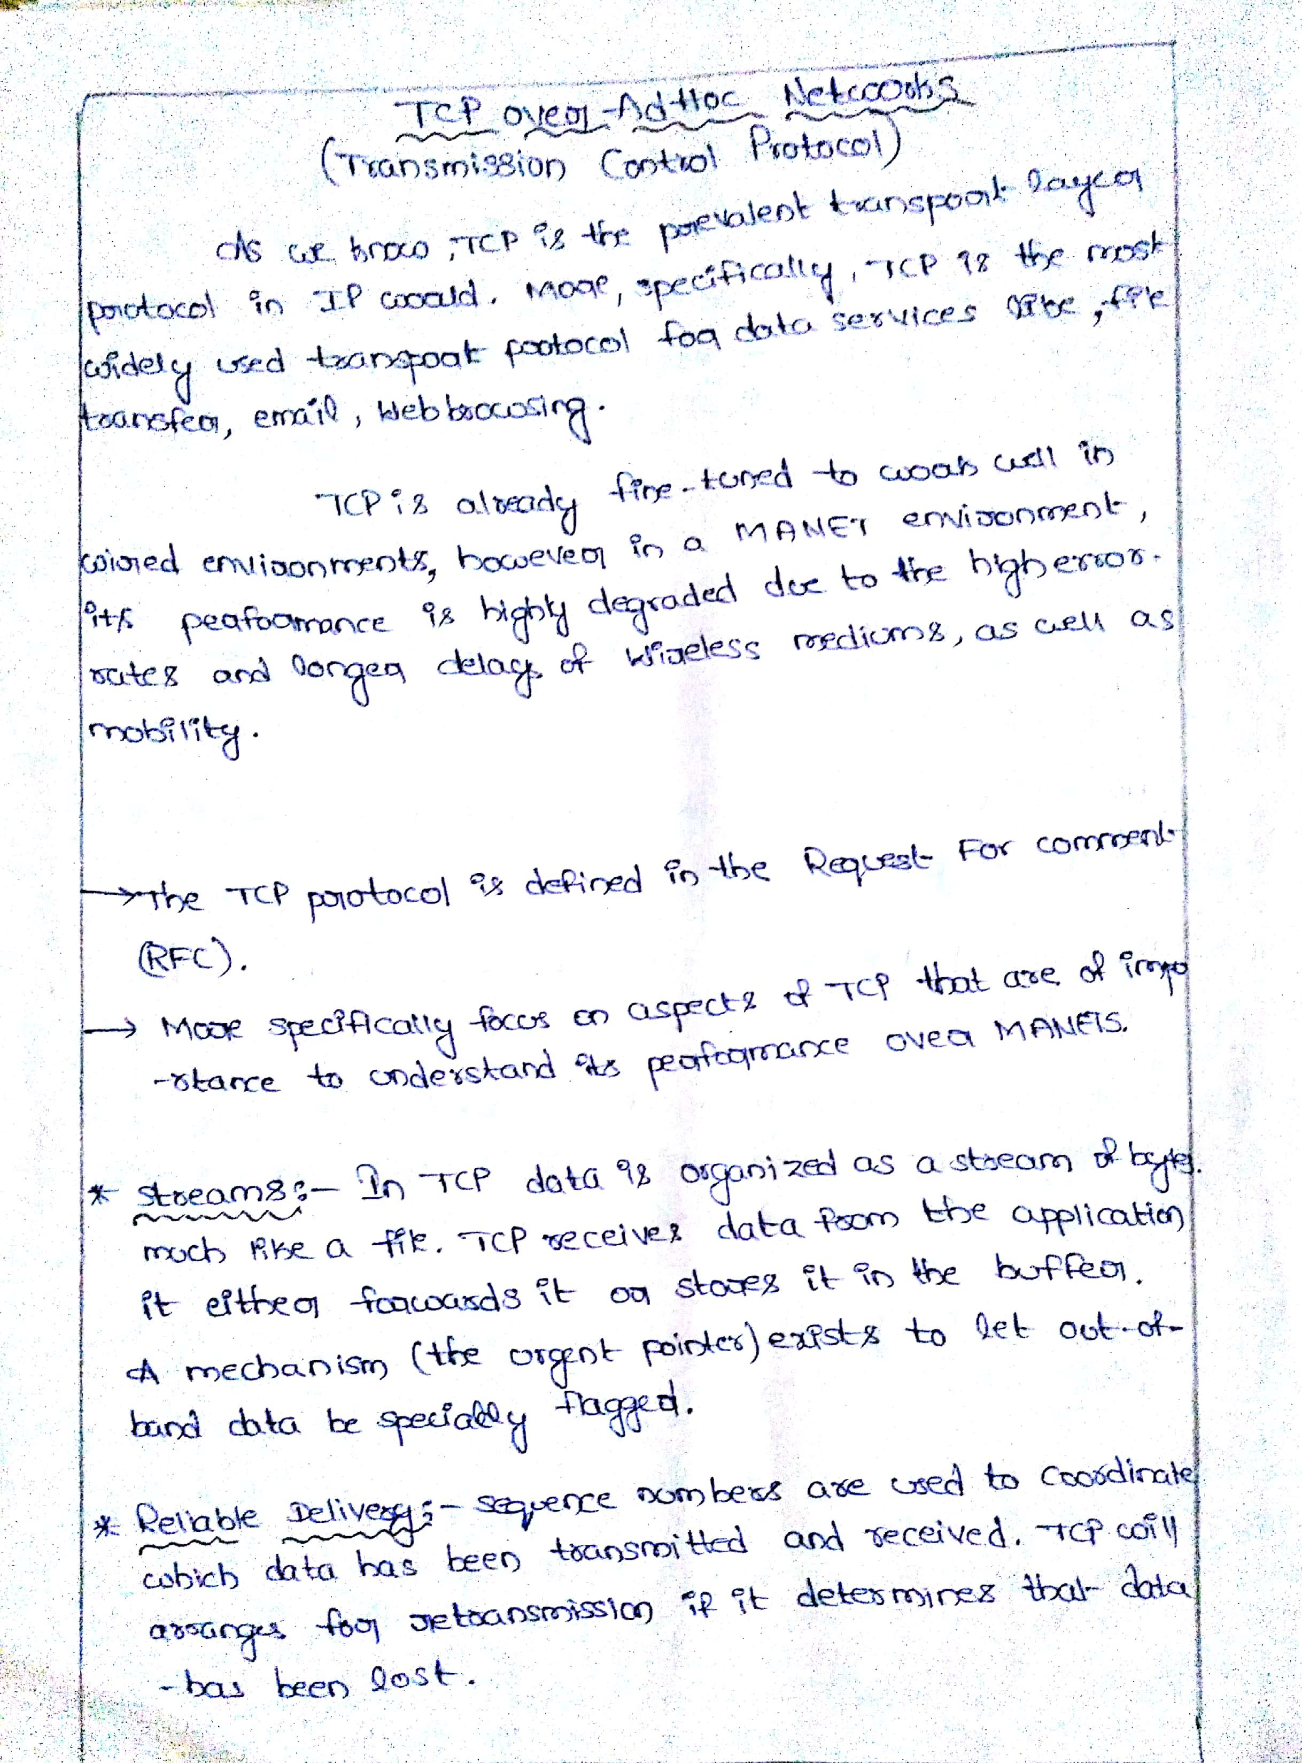**

**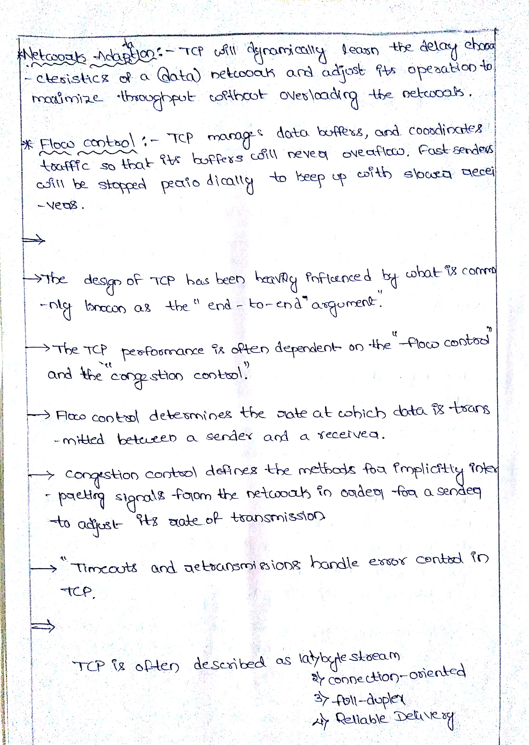**

**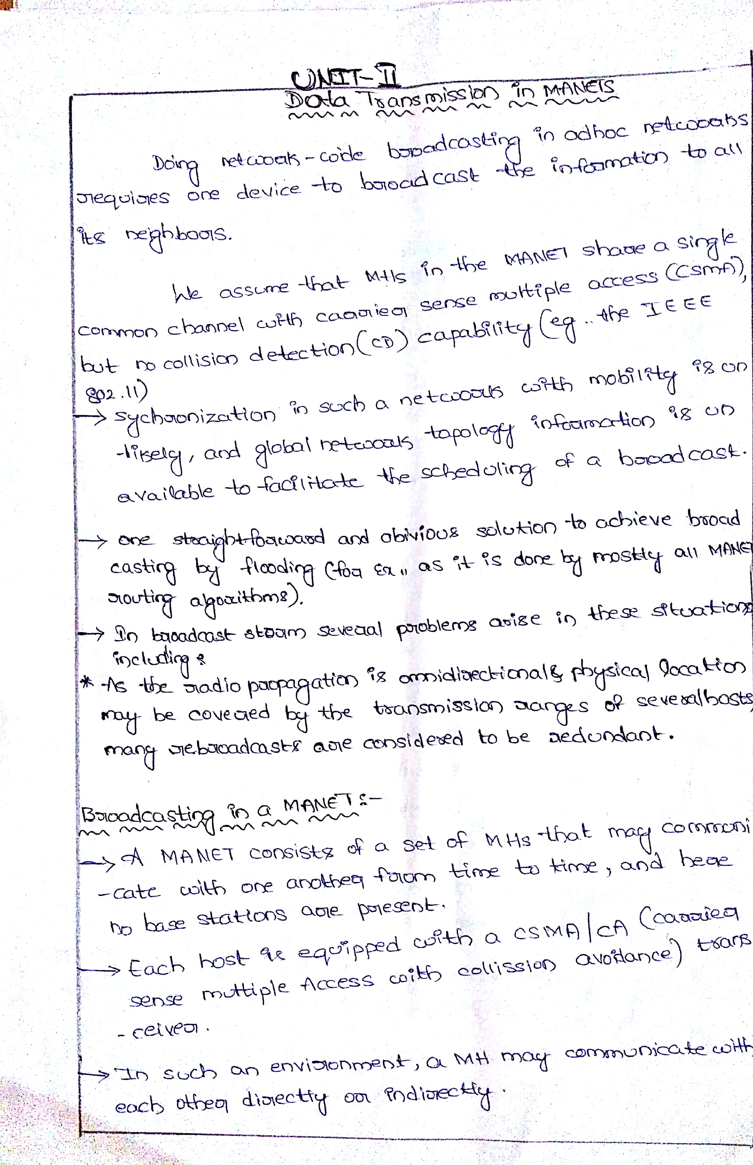**

**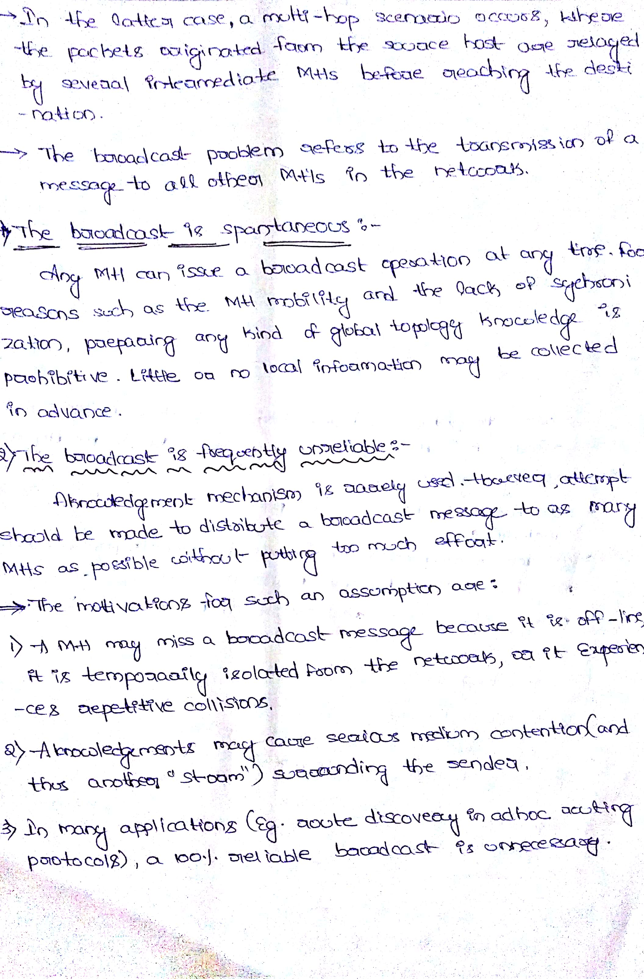**

**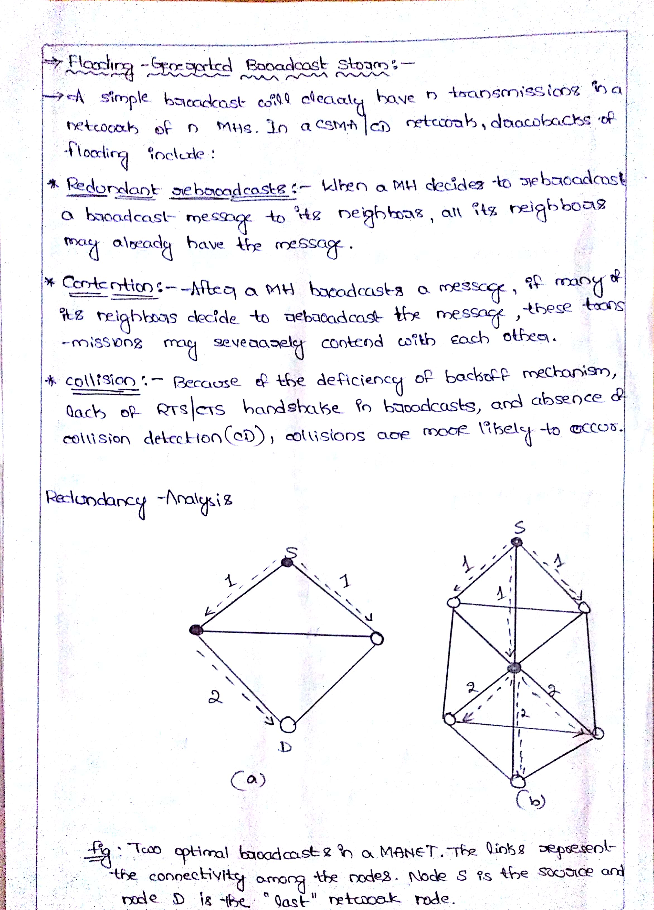**

**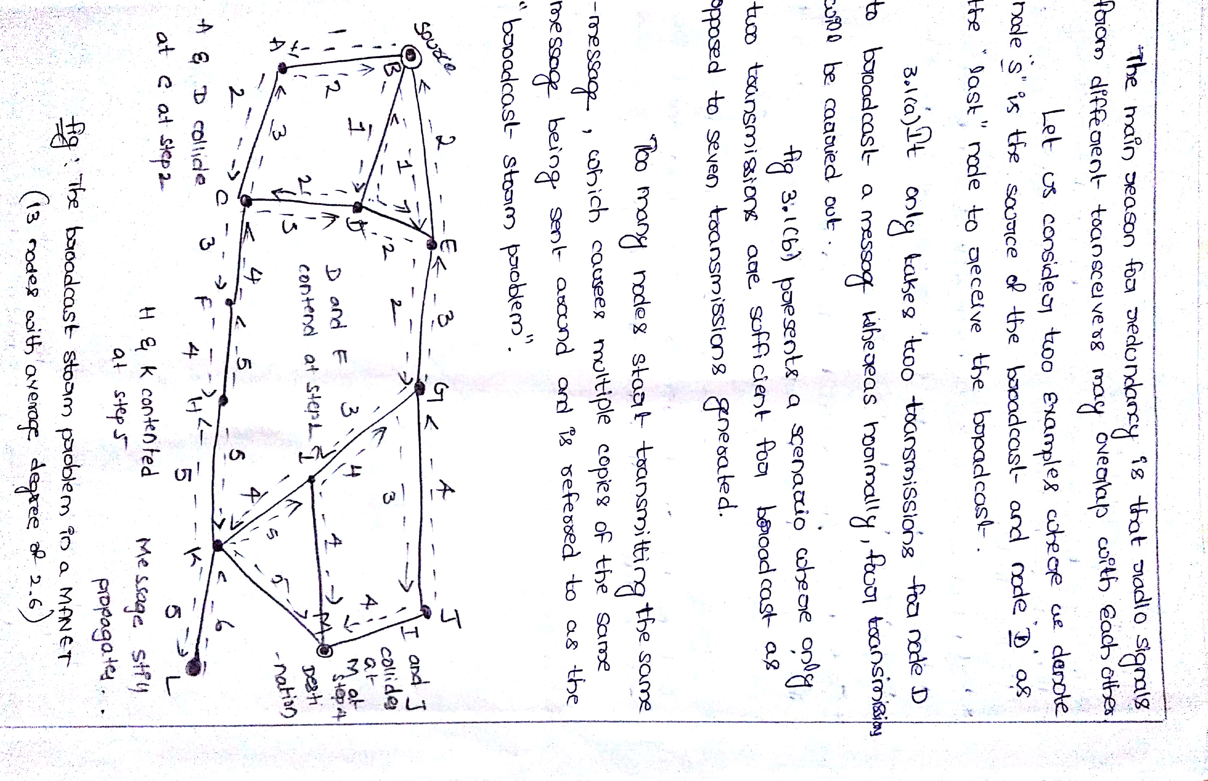**

**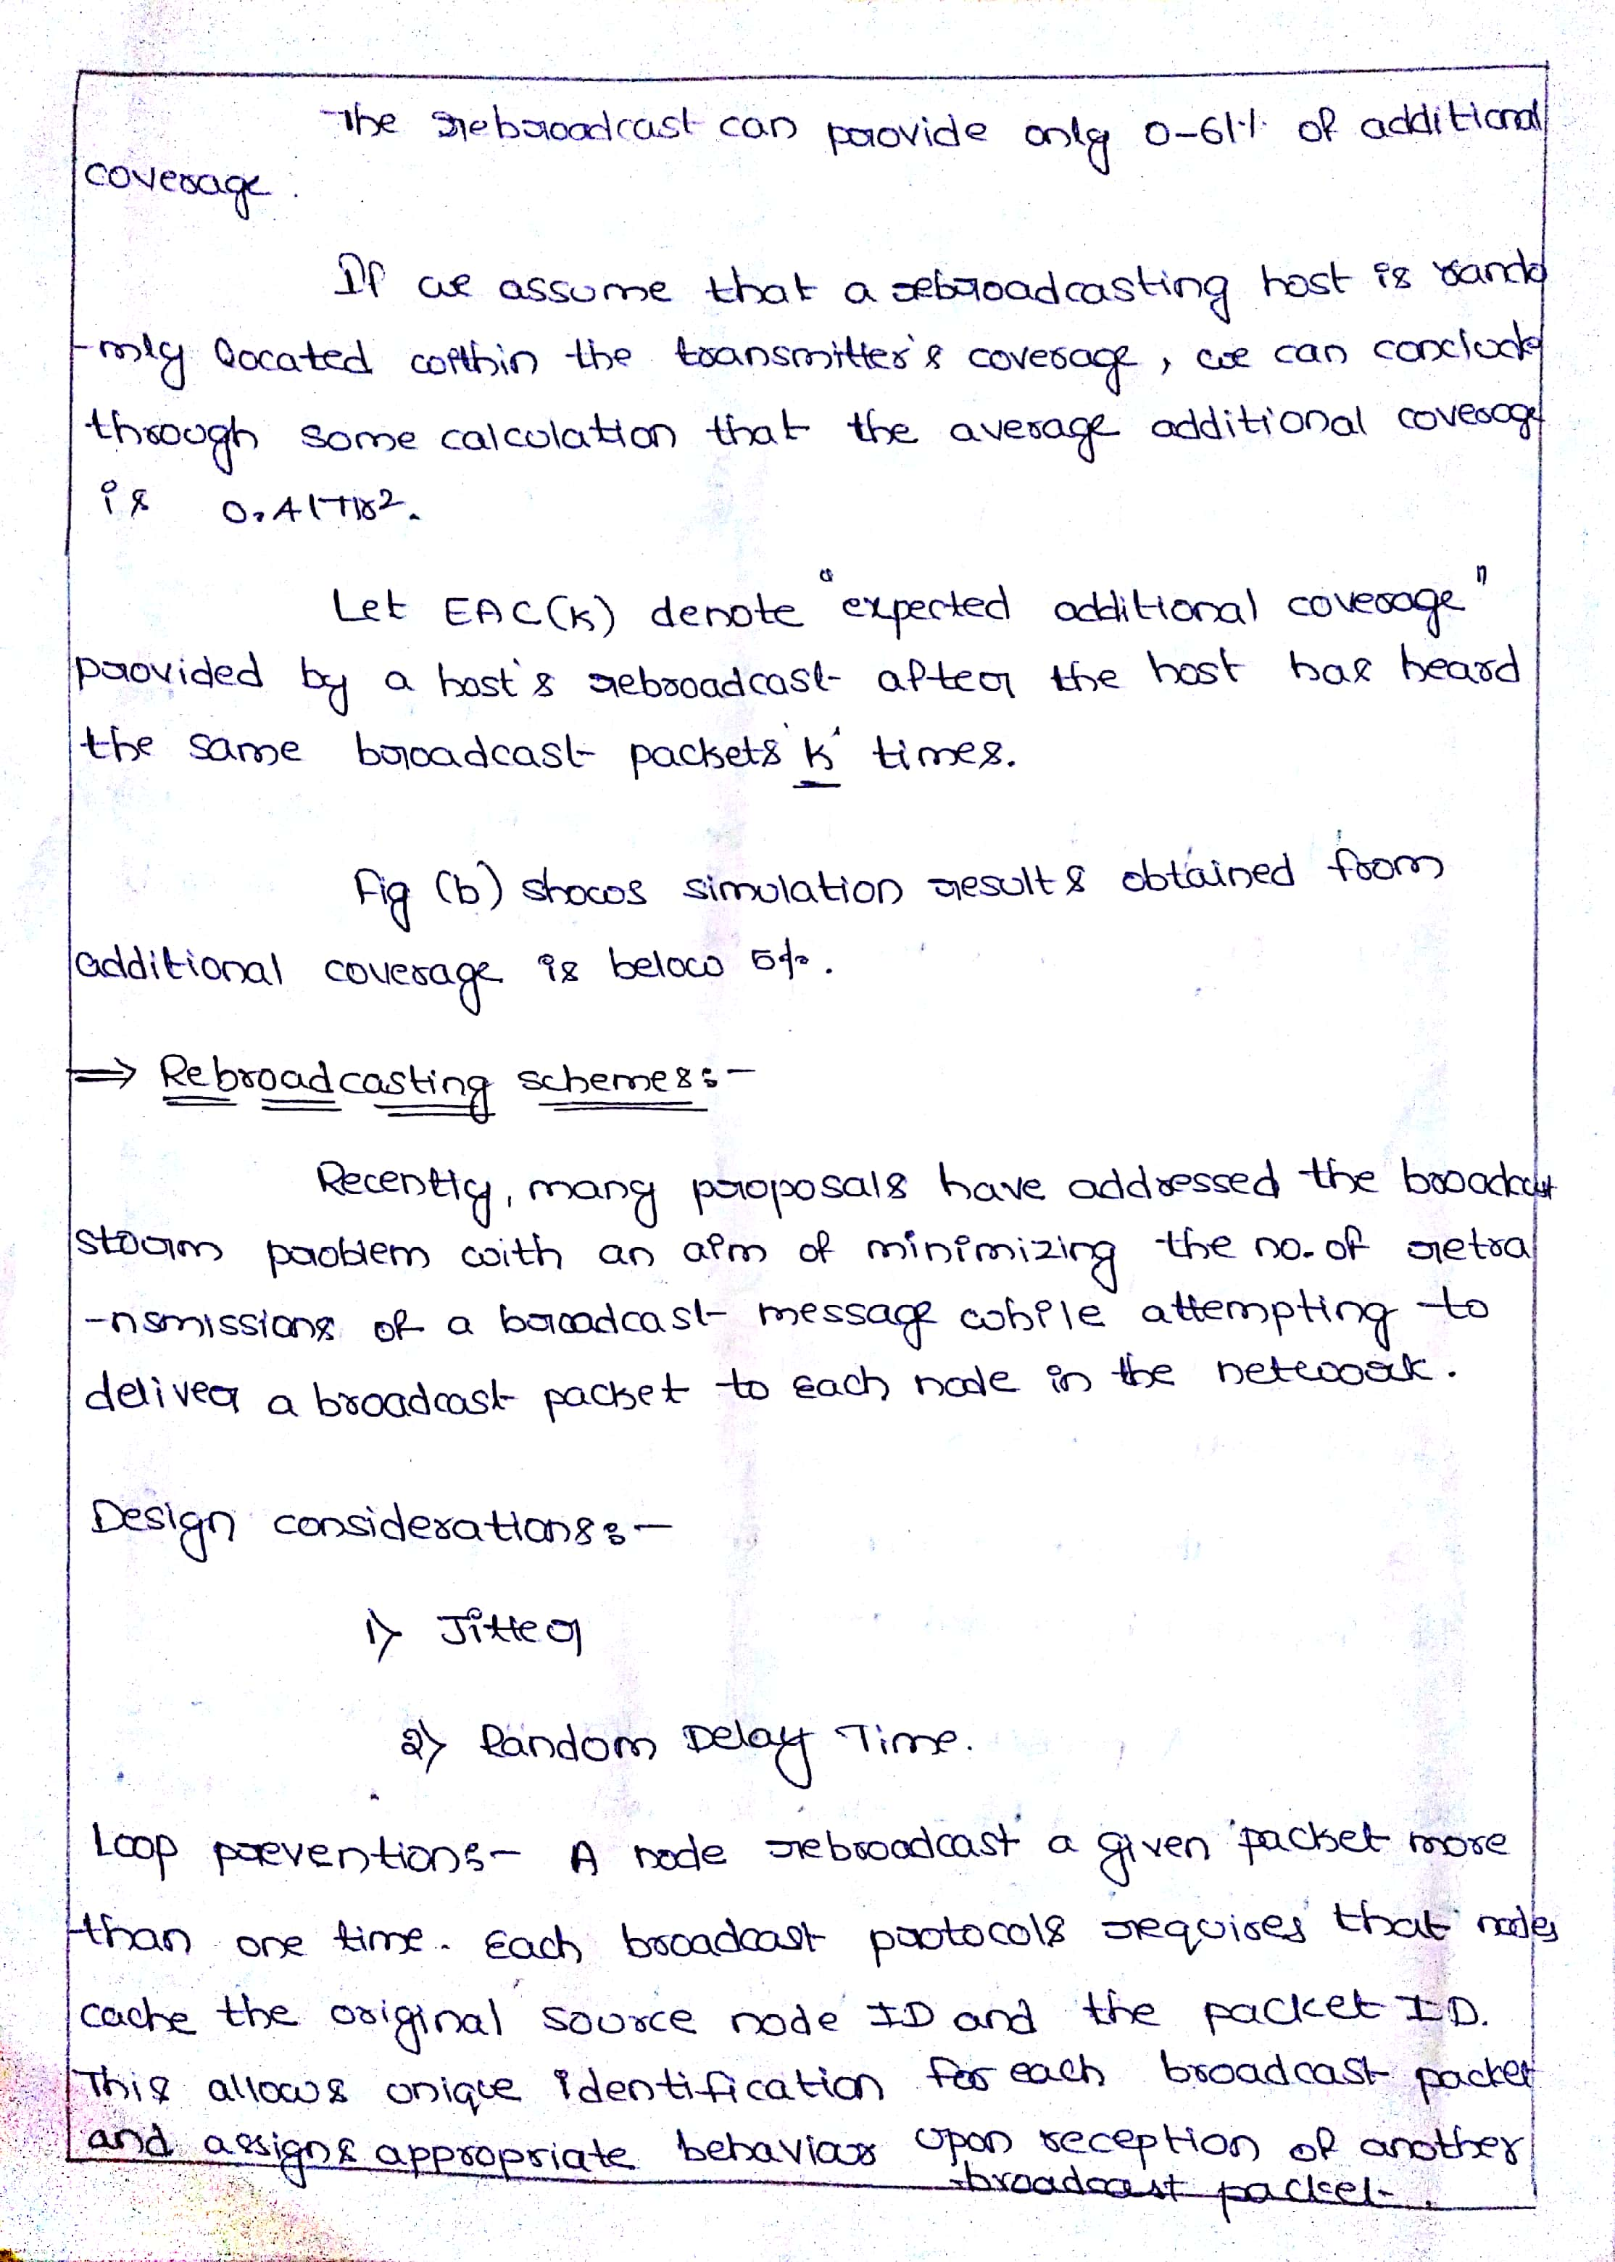**

**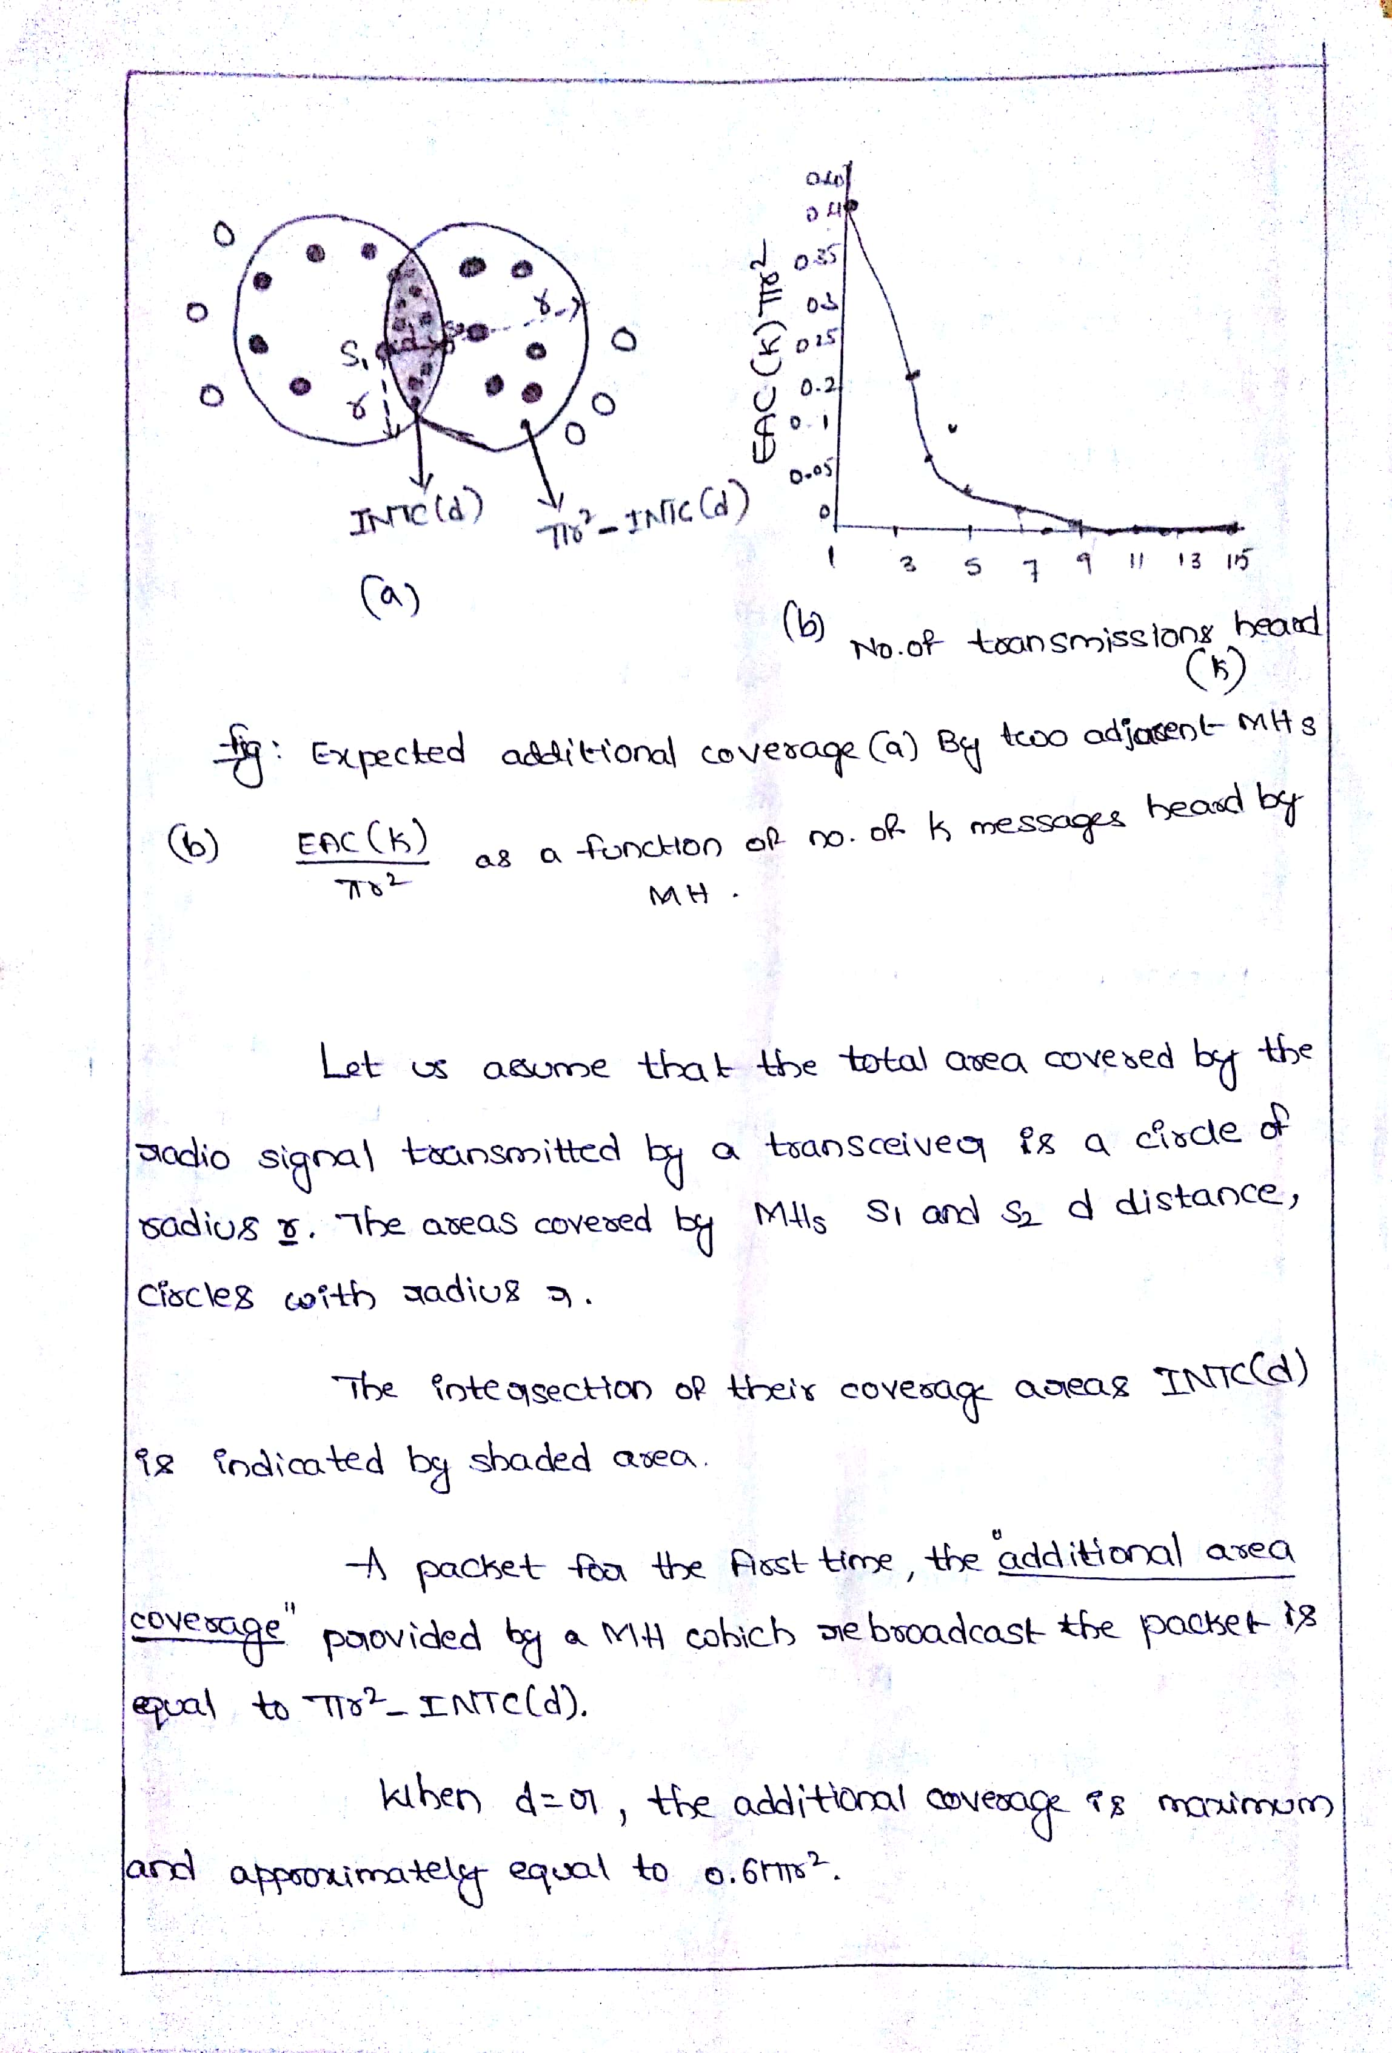**

**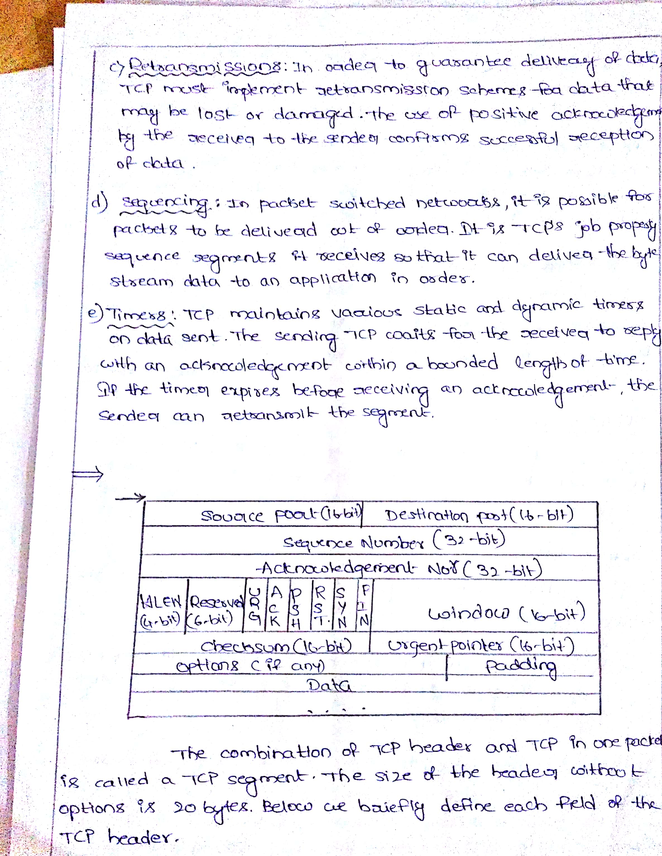**

**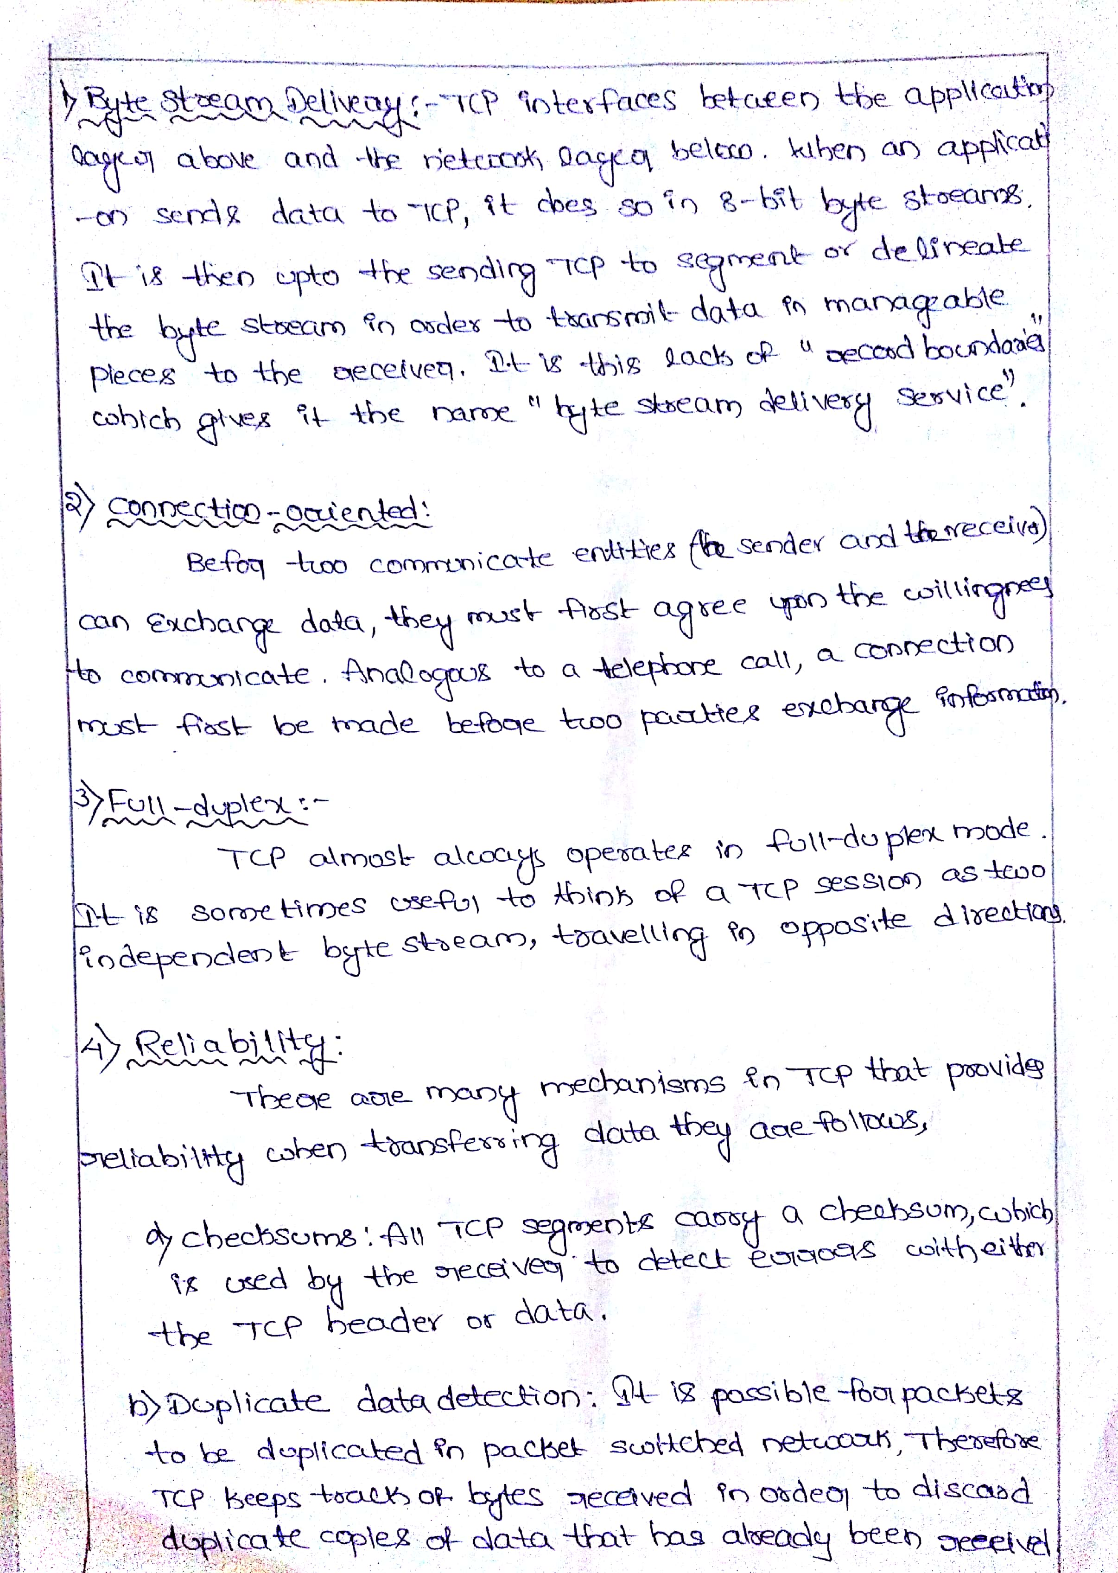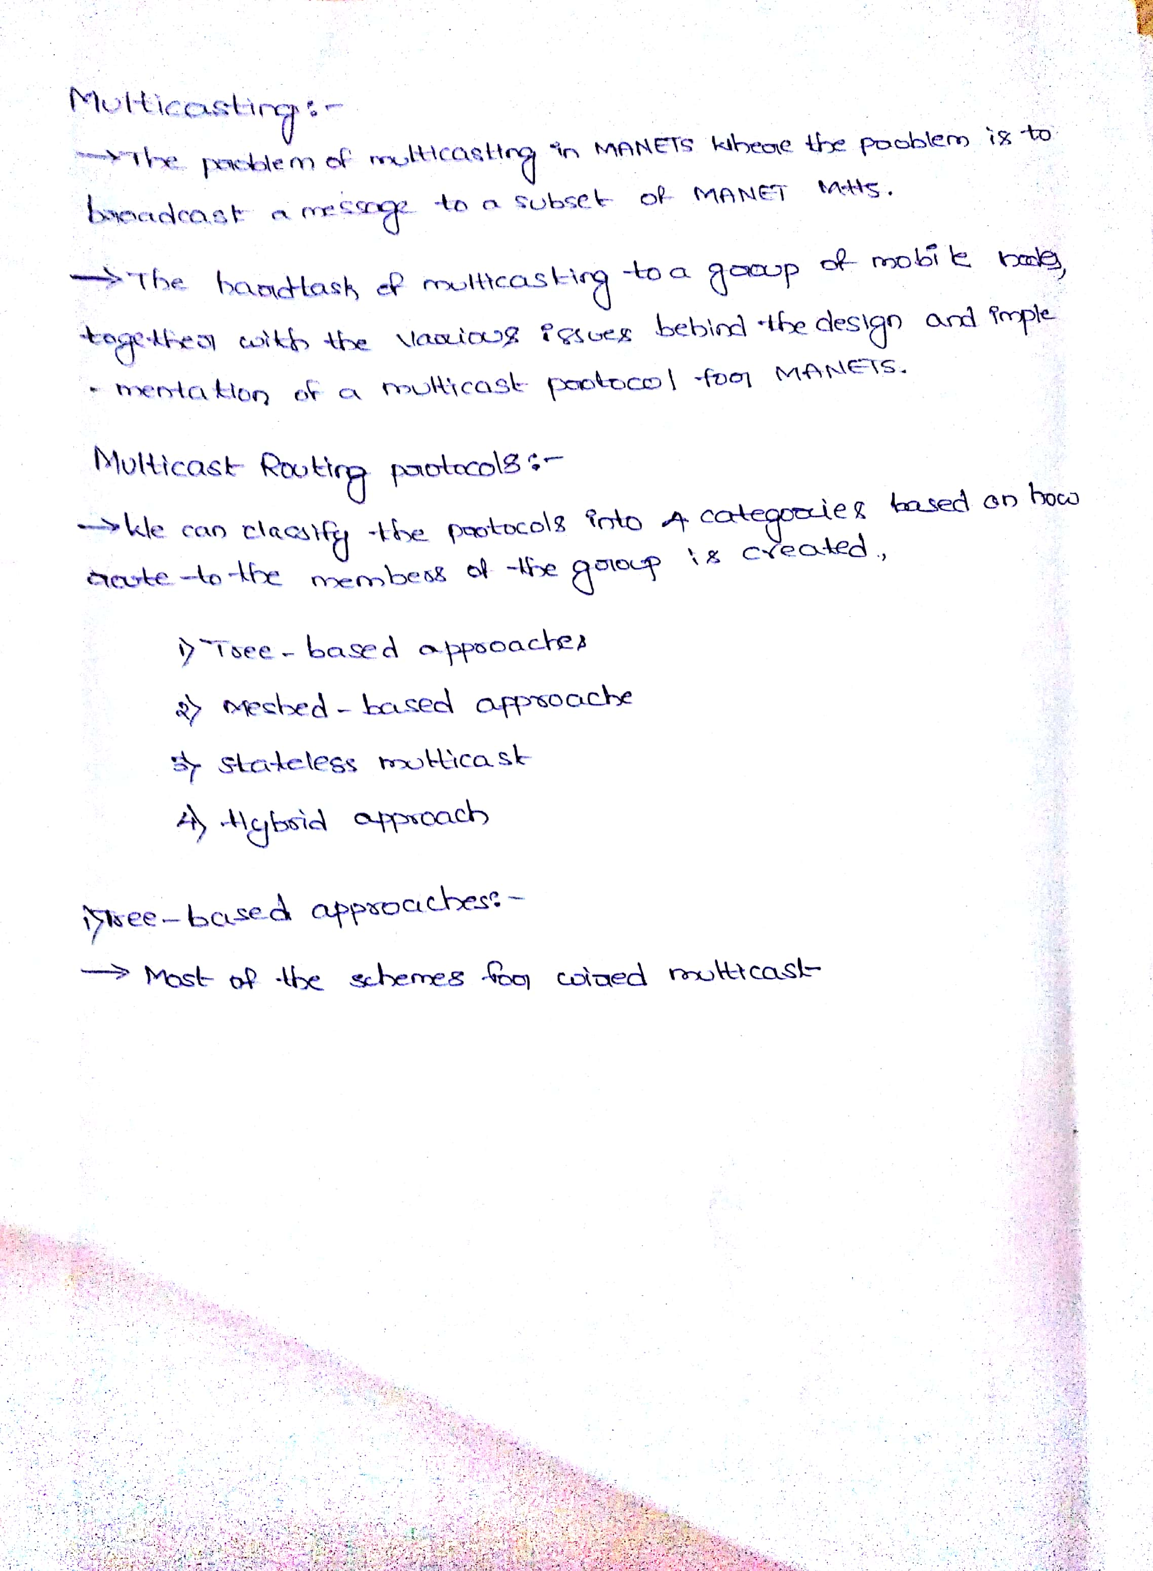**

**8.Assignment Questions along with sample Assignments Scripts**

****

**CMR TECHNICAL CAMPUS**

**Kandlakoya (v), Medchal Road, Hyderabad -501401**

**IV.B.TECH II-SEM,**

**Subject: ASN Branch: IT**

**MID-I ASSIGNMENT QUESTIONS:**

1. Explain briefly the important characteristics of manet?[CO1]
2. Define broadcasting storm problem.Also, discuss the problems encountered in achieving broadcasting by flooding?[CO1]
3. Discuss briefly the principles and issues behind position based routing?[CO2]
4. Explain in detail about Reactive Routing protocols?[CO2]
5. Discuss in brief about, [CO3]
6. Dominant pruning
7. Multipoint relaying

****

**CMR TECHNICAL CAMPUS**

**Kandlakoya (v), Medchal Road, Hyderabad -501401**

**IV.B.TECH II-SEM**

**Subject: ASN Branch: IT**

**MID-II ASSIGNMENT QUESTIONS:**

1. Explain about clustering of sensor networks with examples**(CO4)**
2. List and write about classifications of Wireless Sensor Networks**(CO5)**
3. Explain about secure routing cooperation in MANETs**(CO5)**
4. Write short notes on Node-Level software Platforms**(CO6)**

5.Explain about Node-level Simulators, ns-2 and its sensor networks extension**(CO6)**

**9.Mid exam Question Papers along with sample Answers Scripts**

****

**CMR TECHNICAL CAMPUS**

**Kandlakoya (v), Medchal Road, Hyderabad -501401**

**IV.B.TECH II-SEM-I MID EXAMINATIONS, *Date:* 12.08.2016**

**Subject: ASN Branch: IT Time: 1hr Marks: 2X5=10 M**

**Answer Any Two Questions:**

1.Explain briefly the important characteristics of manet?[CO1]

2.Define broadcasting storm problem. Also, discuss the problems encountered in achieving broadcasting by flooding? [CO1]

3.Discuss briefly the principles and issues behind position based routing? [CO2]

4.Explain in detail about Reactive Routing protocols? [CO2]

****

**CMR TECHNICAL CAMPUS**

**Kandlakoya (v), Medchal Road, Hyderabad -501401**

**IV.B.TECH II-SEM-II MID EXAMINATIONS, NOV-2016 *Date:* 09.11.2016 FN**

**Subject: ASN Branch: IT Time: 1hr Marks: 2X5=10 M**

**Answer Any Two Questions:**

1.Explain about clustering of sensor networks with examples**(CO4)**

2.List and write about classifications of Wireless Sensor Networks**(CO5)**

3.Explain about secure routing cooperation in MANETs**(CO5)**

4.Write short notes on Node-Level software Platforms**(CO6)**

**10. SCHEME OF EVALUATION**

**IV IT A,B1STMID QUESTION**

|  |  |
| --- | --- |
| **Question** | **Scheme of Evolution** |
| 1. Explain briefly the important characteristics of manet?[CO1] | Definition**(1M)**  Explanation**(4M)** |
| 2. Define broadcasting storm problem. Also, discuss the problems encountered in achieving broadcasting by flooding? [CO1] | Definition**(1M)**  Explanation**(3M)** |
| 3. Discuss briefly the principles and issues behind position based routing? [CO2] | Transformation definition**(1M)**  Types of transformations**(2M)**  Examples**(1M)** |
| 4. Explain in detail about Reactive Routing protocols? [CO2] | Definition**(1M)**  Explanation about applications of computer graphics**(4M)** |

**IV CSE A, B&C 1IndMID QUESTIONS**

|  |  |
| --- | --- |
| **Question** | **Scheme of Evolution** |
| **1.** Explain about clustering of sensor networks with examples**(CO4)** | Definition**(1M)**  Explanation about types of projections(4) |
| 2. List and write about classifications of Wireless Sensor Networks**(CO5)** | Definition**(2M)**  Explanation **(3M)** |
| 3. Explain about secure routing cooperation in MANETs**(CO5)** | Definition**(2M)**  Explanation **(3M)** |
| 4.Write short notes on Node-Level software Platforms**(CO6)** | Definition**(2M)**  Explanation **(3M)** |

**11.MAPPING OF COS WITH POS AND PSOS**

|  |  |  |  |  |  |  |  |  |  |  |  |  |  |  |
| --- | --- | --- | --- | --- | --- | --- | --- | --- | --- | --- | --- | --- | --- | --- |
| **CO-PO/MATRIX** | **PO1** | **PO2** | **PO3** | **PO4** | **PO5** | **PO6** | **PO7** | **PO8** | **PO9** | **PO10** | **PO11** | **PO12** | **PSO1** | **PSO2** |
| **C411.1** | **-** | - | - | - | - | - | - | - | - | - | - | 3 | - | - |
| **C411.2** | 3 | 3 | 3 | - | - | - | - | - | - | - | - | - | - | - |
| **C411.3** | 2 | 2 | 2 | - | - | - | - | - | - | - | - | 3 | - | - |
| **C411.4** | 3 | 3 | 2 | - | - | - | - | - | - | - | - | 2 | 3 |  |
| **C411.5** | 2 | 2 | 2 | 3 | 3 | - | - | - | - | - | - | 2 | - | 3 |
| **C411.6** | - | - | - | 2 | - | - | - | - | - | - | - | - | - | 3 |
| **AVERAGE** | **2** | **2** | **2** | **1** | **0** | **0** | **0** | **0** | **0** | **0** | **0** | **2** | **0** | **1** |

**12. ATTAINMENT OF COS, POS AND PSOS (EXCEL SHEET)**

**13. University Question Papers or Question Bank.**

**Unit-I**

1.Explain briefly the important characteristics of manet?

2.Explain briefly different well-known adhoc applications?

3.Explain briefly different well-known adhoc applications?

4.Explainabout Manaets and its scope?

5.Explain in detail about Proactive Routing protocols?

6.Explain in detail about Reactive Routing protocols?

7.Explain in detail about Other Routing protocols?

8. Differentiate between topology based on position based approaches?

9. Discuss briefly the principles and issues behind position based routing?

**Unit-II**

1. Define broadcasting storm problem .Also, discuss the problems encountered in achieving broadcasting by flooding?
2. Discuss briefly the concept of broadcasting in a MANET?
3. Discuss in brief about
4. Flooding-generated broadcast storm

(ii)Redundancy analysis

1. Discuss in brief about,
2. Dominant pruning
3. (b) Multipoint relaying
4. Compare different protocols used for providing multicast over MANETs using various metrics?
5. List the three main different types of challenges posed to TCP over in Adhoc networks?

**Unit-III**

1. Discuss how sensing and communication range is computed for sensor nodes?
2. List the advantages of wireless sensor network over wired networks?
3. Routing protocol design for WSNs is heavily influenced by many challenging factors”. Discuss?
4. Write short notes on
5. sensing transducer
6. A/D converter
7. Transmission energy and receiver energy
8. Computing Unit
9. Write short notes on
10. Regularly placed sensors
11. Randomly distributed sensors
12. Heterogeneous sensors
13. Mobile sensors.
14. Explain briefly the types of schemes available to allocate a single broadcast channel among competing nodes?
15. Explain in detail the sensor MAC Protocol?
16. Explain in detail about the different flat routing protocols

**Unit-IV**

1. Write short notes on,

a)Key Management

b)Intrusion Detection system

c)Secure Routing

2. Discuss in brief about,

a)Trusted third parties

b)Chain of trust

3. a) Explain in detail about Diffie-Hellman key agreement.

b) Discuss in detail about N-party Diffie-Hellman key agreement.

4. Draw and Explain IDS architecture for ad hoc networks?

5. Explain in detail the anomaly detection issues in IDS systems?

6. Explain in detail the different categories of sensor node hardware?

7. Draw and explain in detail about MICA note architecture?

8. Explain about the challenges faced in sensor network Programming?

9. Discuss in brief about node-level platform?

**Unit-V**

. Explain in detail about TinyOS?

2. Discuss in detail the component interface as well as component Implementation in Nesc?

3. Explain how concurrency is supported in nesc?

4. Explain in detail about TinyGALS programming model?

5. Explain in detail about simulator ns-2?

**14Power Point Presentations: (softcopy)**

**15.WEBSITES OR URLS E- RESOURCES**

1. [www.cs.princeton.edu](http://www.cs.princeton.edu" \t "_blank)
2. <http://sureshq.blogspot.in/2016/12/wireless-sensors-networks-wsn-notes-and.html>
3. [www.cs.ucl.ac.uk](http://www.cs.ucl.ac.uk)
4. [www.comp.nus.edu.sg](http://www.comp.nus.edu.sg)
5. [www.iitk.ac.in](http://www.iitk.ac.in)
6. [www.iitd.ernet.in](http://www.iitd.ernet.in)
7. [www.iitr.ac.in](http://www.iitr.ac.in)
8. [www.iitg.ernet.in](http://www.iitg.ernet.in)
9. [www.bits-pilani.ac.in](http://www.bits-pilani.ac.in)
10. [www.iisc.ernet.in](http://www.iisc.ernet.in)